**Login Module:**

Ok

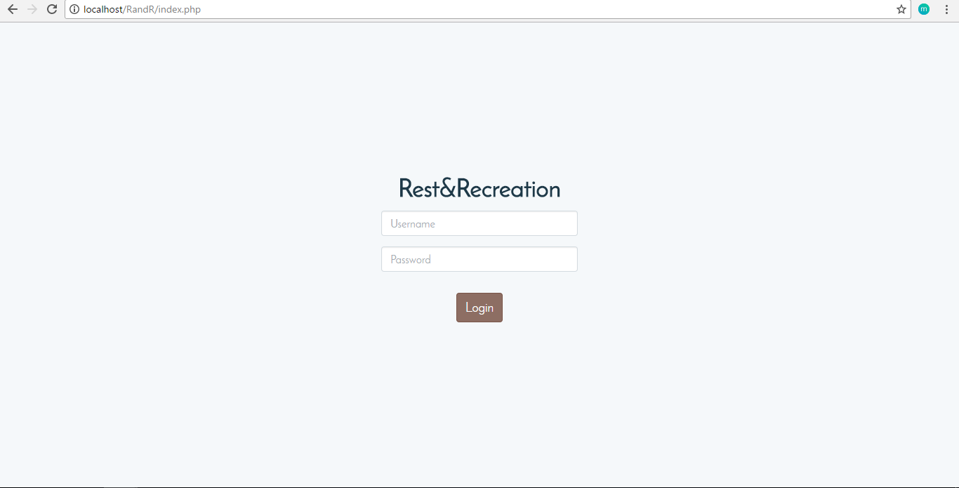

Suggested Improvements:

If login details is incorrect, error message must state why the login is wrong: User does not exist, Wrong Username or Wrong Password.

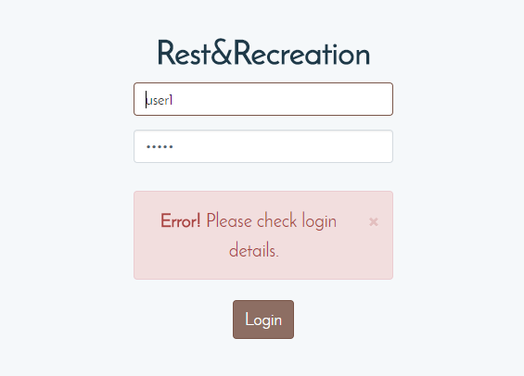

Problems: Login color theme (light brown) does not match the site (sky bluish).

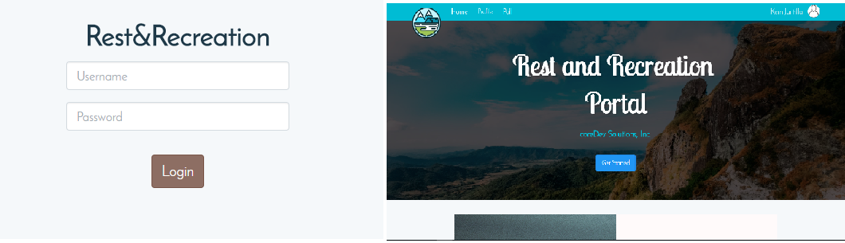

**Sessions Module:**

Ok. Session class is working good.

Administrator:



Member:



If a member (non-admin user) goes to pages only Administrator can access, it will redirect the user to a Error 403 page (Forbidden).

Listed are pages ONLY Administrators can access:

* Users(User Type, Register and Edit Users pages)
* Events(Create Event, Activity and Checklist pages)

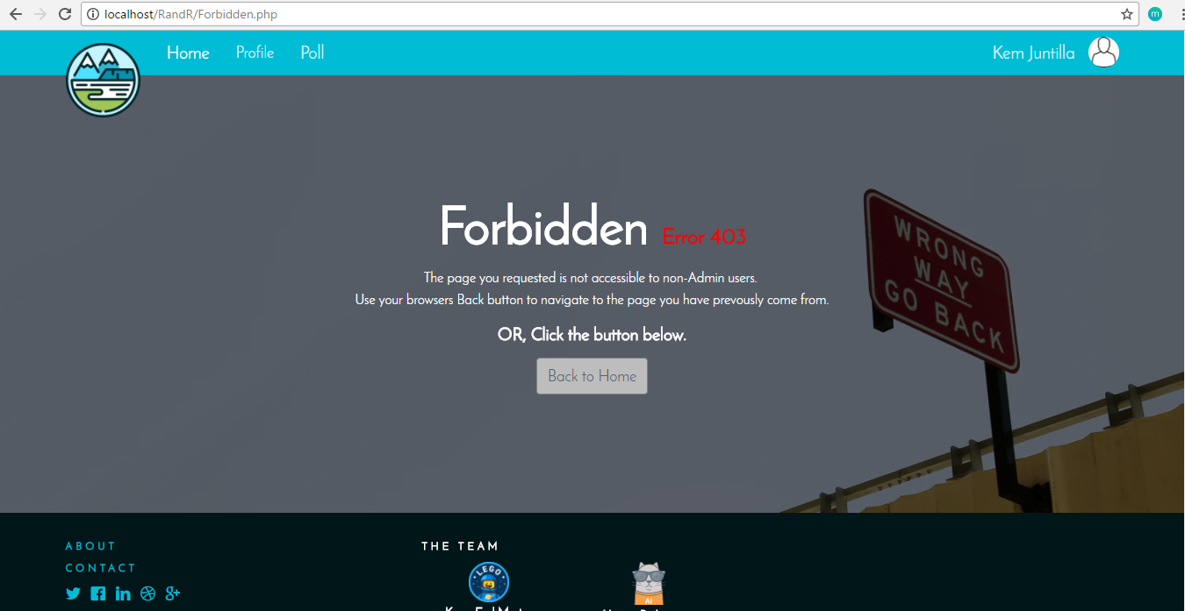

Suggested Improvements:

**Users Module:**

User Interface needs improvement. UI is not tested for use, might cause confusion when an administrator wants to manage the users.

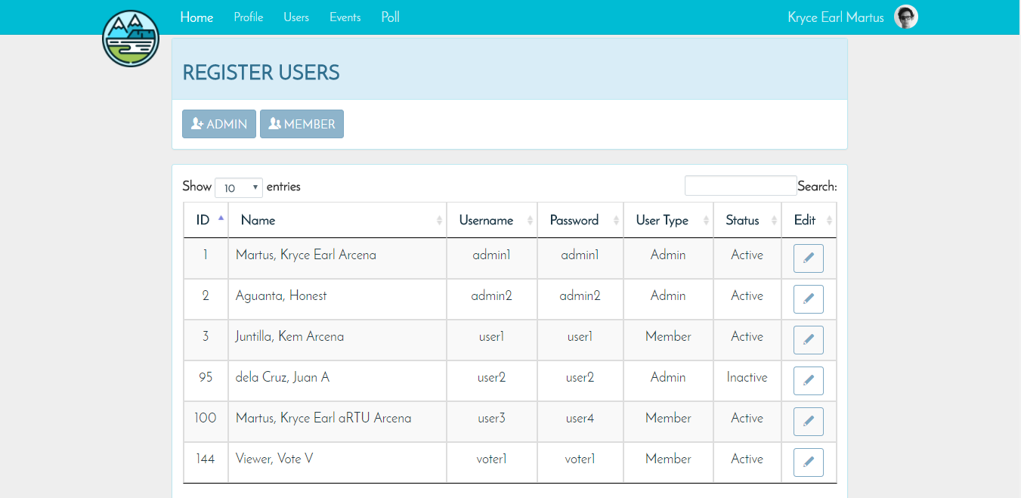

Suggested Improvements:

Due to some unknown reason, The label and the textbox used for searching users in the data type are switched. It is believed a code in the CDN used for the data table has been changed or modified.

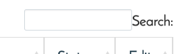

**User Registration:**

Ok. There two pages to create user accounts, for Members and Administrator respectively.

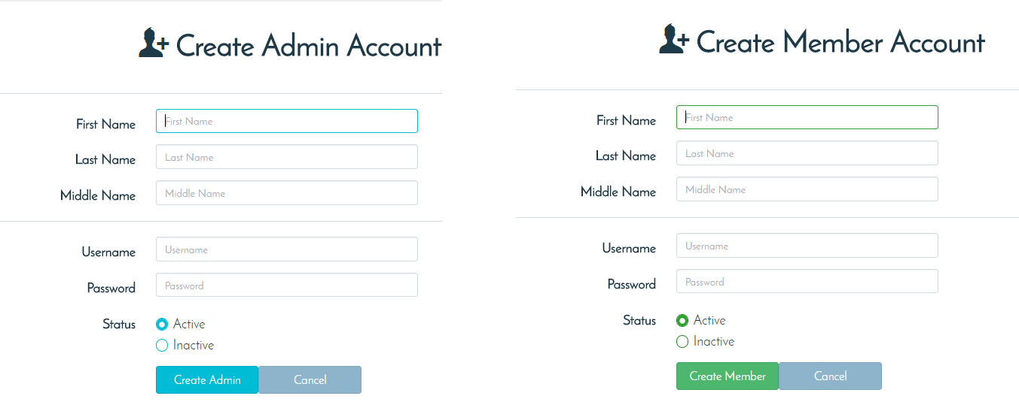

Suggested Improvements:

The two pages are basically the same. This should be one page instead, with a radio or toggle input to declare what type of user the admin is going to create or register.

Drop down options inside “Users” on the navigation states ‘Administrator’ and ‘Member’ are too vague, the options leads to the registration of the users. The options must be change so that the administrator will now that the options are for registration.

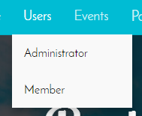

When registering a user, if the login details are invalid, the data filled in by the Admin should remain after the submission of form.

Before Registering invalid login details: After submission:

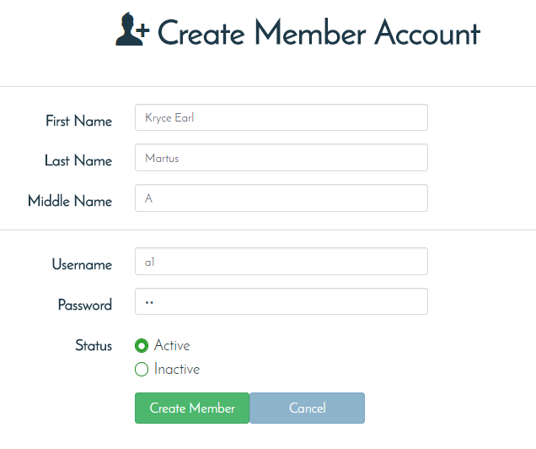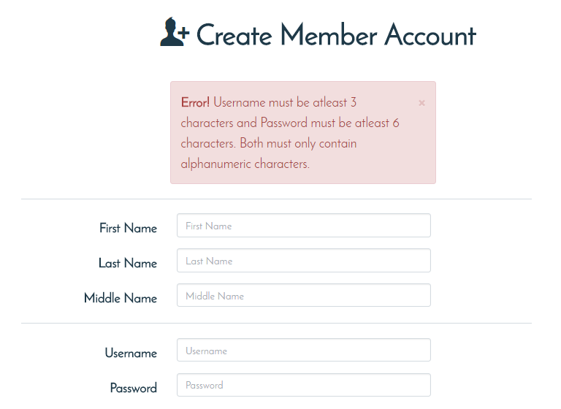

**Edit User:**

Ok

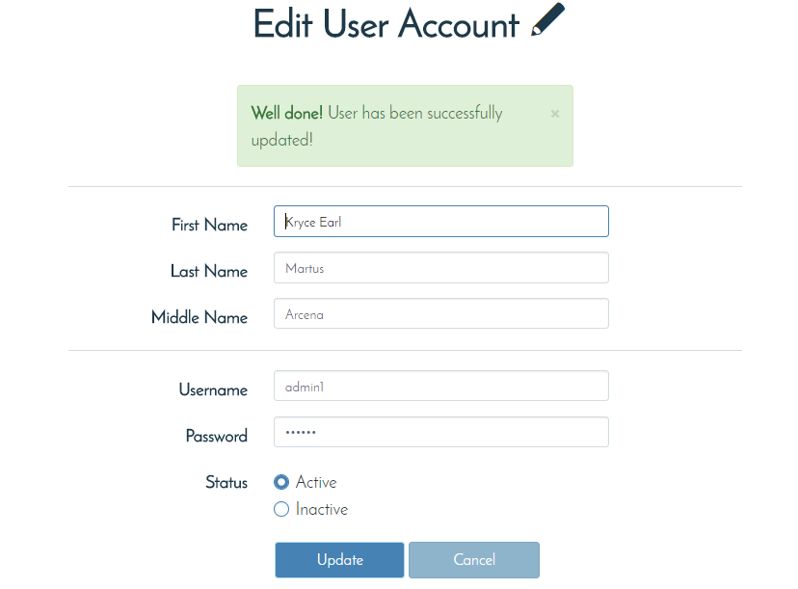

User Profiles:

Pending. Profiles are made simple using info cards. Users can’t update their profile picture yet.

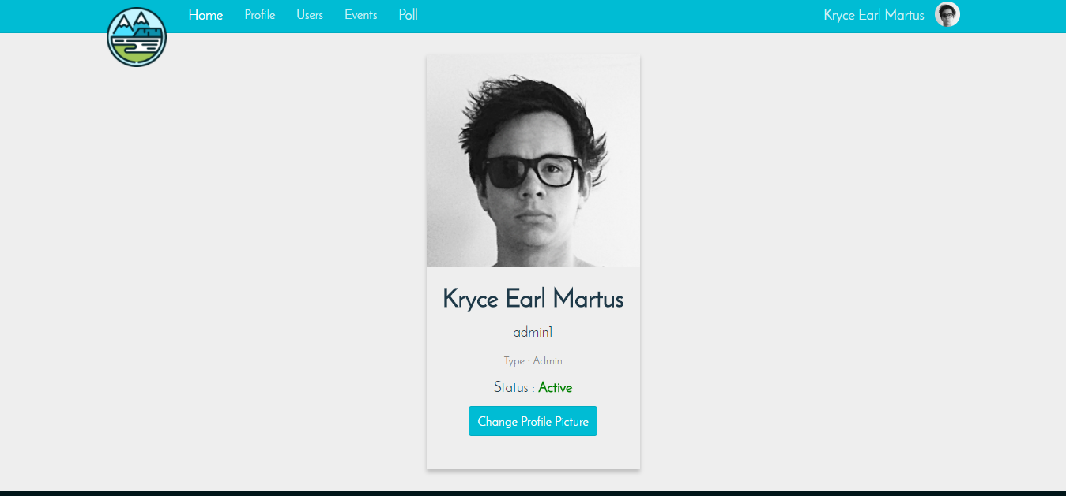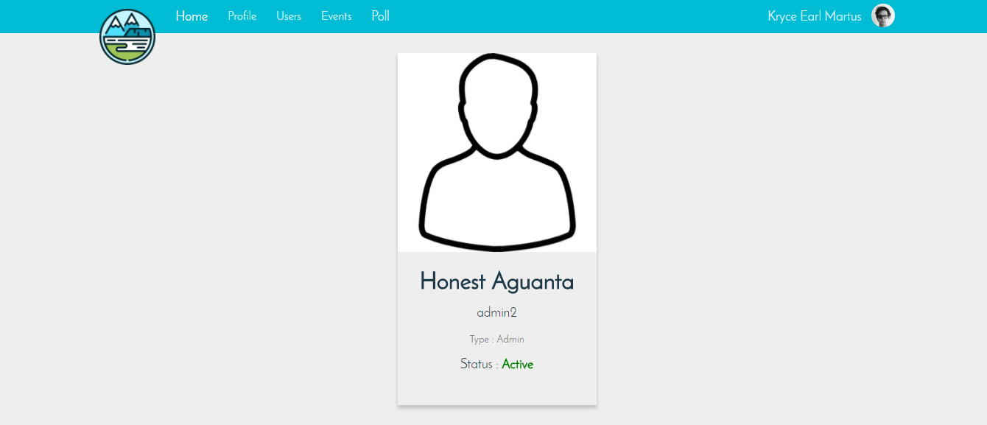

Visiting other profile will give you the same layout except the Change profile picture button.

**Events Module:**Ok.

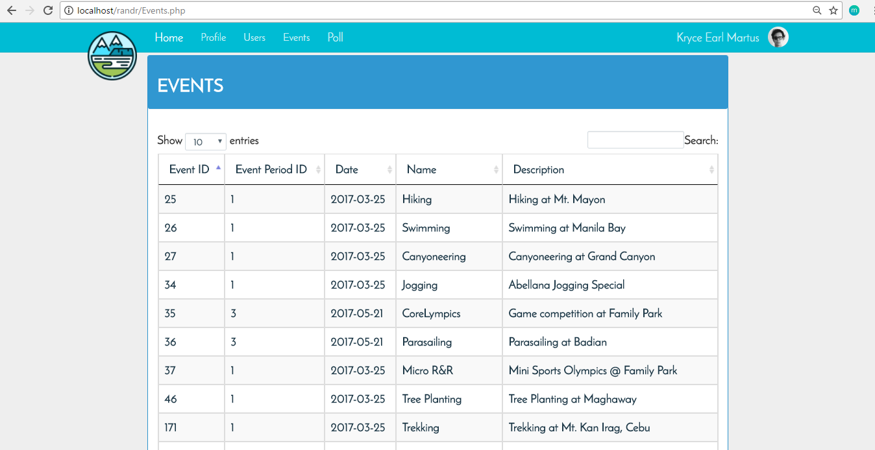

**Create events:**

Ok

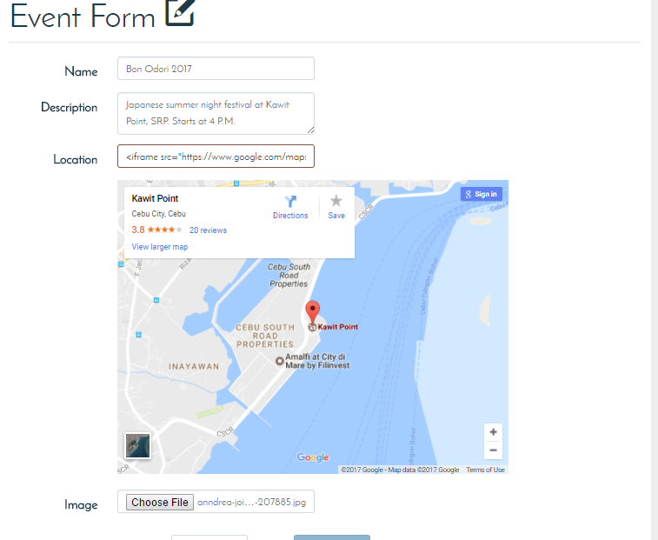

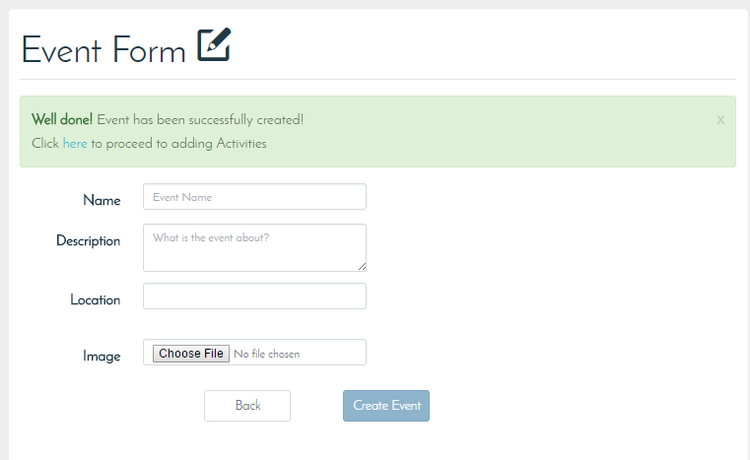

Suggested Improvements: